**Assignment 4**

**Task 1: Stock Market Analysis**

**Objective: Analyzing the performance of MICROSOFT Corporation over the past year.**

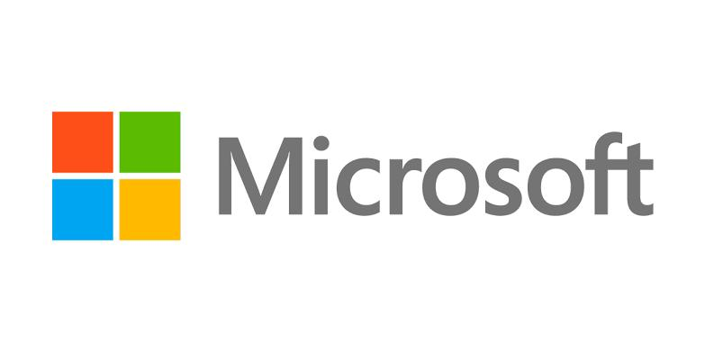**INTRODUCTION**

Microsoft was founded by Bill Gates and Paul Allen on April 4, 1975, to develop and sell BASIC interpreters for the Altair 8800. It rose to dominate the personal computer operating system market with MS-DOS in the mid-1980s, followed by Windows. The company's 1986 initial public offering (IPO) and subsequent rise in its share price created three billionaires and an estimated 12,000 millionaires among Microsoft employees. Since the 1990s, it has increasingly diversified from the operating system market and has made several corporate acquisitions, the largest being the acquisition of Activision Blizzard for $68.7 billion in October 2023,[4] followed by its acquisition of LinkedIn for $26.2 billion in December 2016,[5] and its acquisition of Skype Technologies for $8.5 billion in May 2011.[6]

Microsoft is a global technology powerhouse renowned for its innovative software solutions and cutting-edge technologies. With a rich history spanning decades, Microsoft has consistently pushed the boundaries of what's possible in computing, productivity, and entertainment. From its iconic Windows operating system to its cloud computing platform Azure and productivity suite Office 365, Microsoft has left an indelible mark on the world of technology. With a commitment to empowering individuals and organizations to achieve more, Microsoft continues to shape the future of computing and drive digital transformation across industries worldwide.

**Key businesses**

Certainly, Microsoft operates across several key businesses, each contributing to its diverse portfolio and global impact:

1. *Cloud Computing (Azure)*: Microsoft Azure is a leading cloud computing platform providing a wide range of services such as computing, storage, databases, machine learning, and more.

2. *Productivity and Business Processes*: This segment includes Microsoft Office products like Word, Excel, PowerPoint, Outlook, Teams, and SharePoint, as well as Dynamics 365 for customer relationship management (CRM) and enterprise resource planning (ERP) solutions.

3. *Personal Computing*: This category encompasses Windows operating system licensing, devices like Surface tablets and laptops, gaming consoles (Xbox), and search advertising through Bing.

4. *LinkedIn*: As the world's largest professional network, LinkedIn offers various services for networking, job searching, professional development, and talent acquisition.

5. *Gaming*: Microsoft's gaming division includes Xbox hardware, software, and services, such as Xbox consoles, Xbox Live, Xbox Game Pass, and first-party game development studios like Xbox Game Studios.

**Data Analysis**

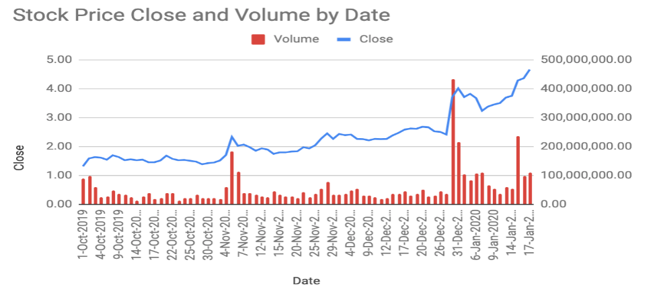

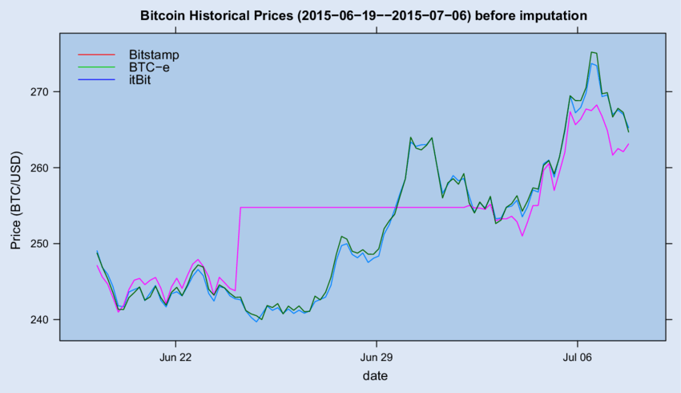

**Key metrics**

Key metrics of Microsoft encompass various aspects of its business performance and financial health. Some of the key metrics include:

1. \***Revenue**\*: Microsoft's total revenue across its various business segments, including revenue from product sales, subscriptions, and services.

2. \***Net Income**\*: The amount of profit left after deducting all expenses from total revenue.

3. **\*Operating Income\***: The income generated from Microsoft's core business operations, excluding non-operating expenses such as interest and taxes.

4. **\*Gross Margin*:** The percentage of revenue remaining after subtracting the cost of goods sold (COGS) from total revenue, indicating Microsoft's profitability on its products and services.

5. **\*Cloud Revenue Growth\***: Microsoft's revenue growth specifically from its cloud computing services, including Azure and Office 365, reflecting the company's success in capturing market share in the cloud industry.

6. **\*Azure Revenue\***: Revenue specifically generated from Microsoft Azure, indicating the growth and adoption of its cloud platform.

7. **\*Office 365 Subscribers\***: The number of subscribers to Microsoft's Office 365 suite, representing the recurring revenue generated from its productivity software.

8. **\*Xbox Live Active Users\***: The number of active users on Microsoft's Xbox Live gaming platform, reflecting engagement and potential for revenue from gaming services and subscriptions.

9. **\*Commercial Licensing Segment Revenue\***: Revenue generated from licensing Windows, Office, and other commercial software products to businesses and organizations.

10. **\*LinkedIn Revenue\***: Revenue generated from LinkedIn's various services, including talent solutions, marketing solutions, and premium subscriptions.

11. **\*Free Cash Flow\***: The amount of cash generated by Microsoft's operating activities after accounting for capital expenditures, indicating the company's ability to generate cash for future investments and dividends.

**Historical annual stock price data**

Historical daily share price chart and data for Microsoft since 1986 adjusted for splits and dividends. The latest closing stock price for Microsoft as of April 02, 2024 is **421.44**.

* The all-time high Microsoft stock closing price was **429.37** on **March 21, 2024**.
* The Microsoft 52-week high stock price is **430.82**, which is **2.2%** above the current share price.
* The Microsoft 52-week low stock price is **275.37**, which is **34.7%** below the current share price.
* The average Microsoft stock price for the last 52 weeks is **352.23**.

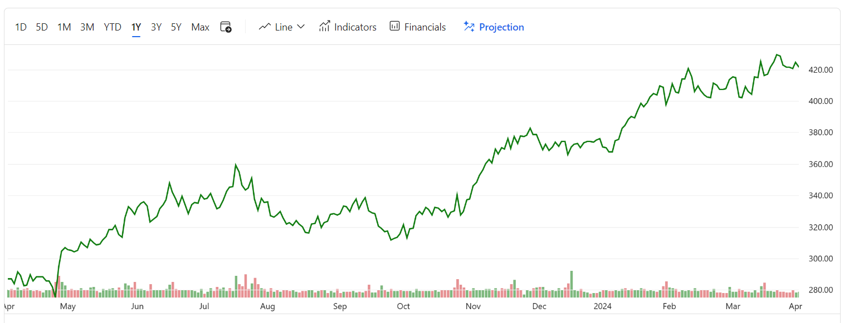

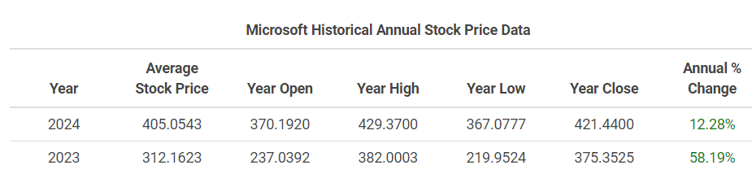

**Volatility**

The volatility of Microsoft's stock can be assessed by looking at its historical price movements and fluctuations in the stock market. Here are some factors that may contribute to the volatility of Microsoft's stock:

1. \***Market** **Sentiment**\*: Changes in overall market sentiment, economic conditions, and investor confidence can impact the volatility of Microsoft's stock, as with any other publicly traded company.

2. \***Earnings** **Reports**\*: Microsoft's quarterly earnings reports can significantly affect its stock price. Positive earnings surprises or strong revenue growth may lead to a rise in the stock price, while missed earnings expectations or lower-than-expected revenue may lead to a decline.

3. \***Product** **Releases and Updates**\*: Announcements of new products, updates to existing products, or developments in key business segments (such as cloud computing, gaming, or productivity software) can influence investor perceptions and stock price volatility.

4. \***Competitive Landscape**\*: Changes in competition, including the introduction of new technologies or services by competitors, can impact Microsoft's stock price and contribute to volatility.

5. \***Regulatory Environment**\*: Changes in regulations or legal proceedings, such as antitrust investigations or data privacy concerns, can affect investor sentiment and contribute to stock price volatility.

6. \***Macroeconomic Factors**\*: Economic indicators, geopolitical events, and global market trends can also influence the volatility of Microsoft's stock, as they do with other companies in the technology sector.

7. \***Investor Expectations**\*: Changes in investor expectations, analyst recommendations, or institutional investor activity can contribute to fluctuations in Microsoft's stock price.

While Microsoft is generally considered a stable and well-established company, its stock can still experience periods of volatility due to various internal and external factors. Investors should carefully consider these factors and conduct thorough research before making investment decisions.

**Average trade volume**

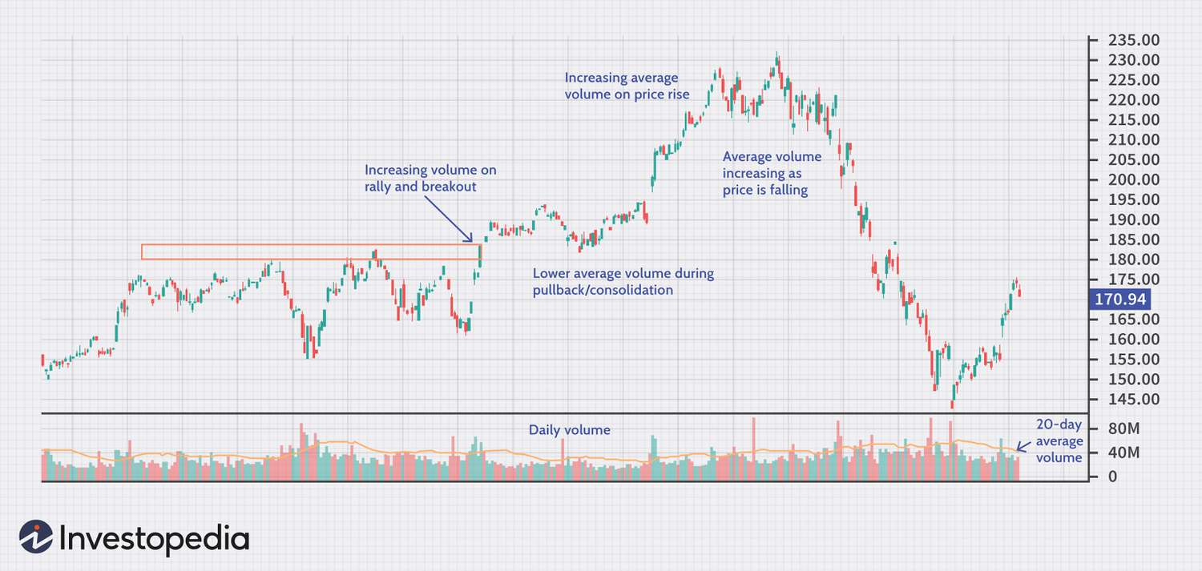

**Stock comparison and analysis**

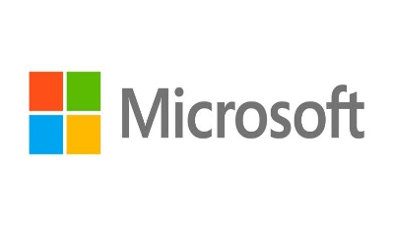 **VS **

|  |  |  |  |  |  |
| --- | --- | --- | --- | --- | --- |
| Symbol | MSFT | NFTY |  |  |  |
| Company | Microsoft Corp | FT India Nifty 50 EW ETF |  |  |  |
| **Price Information** |  | | | | |
| Exchange | NASDAQ | NASDAQ |  |  |  |
| Open | 420.11 | 57.23 |  |  |  |
| High | 422.38 | 57.29 |  |  |  |
| Low | 417.84 | 56.89 |  |  |  |
| Last | 421.44 | 57.01 |  |  |  |
| Change | -3.13 | -0.19 |  |  |  |
| % Change | -0.74% | -0.33% |  |  |  |
| Volume | 17,911,900 | 62,900 |  |  |  |
| 20-Day Average Volume | 21,262,635 | 31,945 |  |  |  |
| Previous Close | 424.57 | 57.20 |  |  |  |
| Industry | Computer - Software | N/A |  |  |  |
| Has Options | Yes | Yes |  |  |  |
| **Technicals** |  | | | | |
| 20-Day Moving Average | 417.57 | 56.63 |  |  |  |
| 20-Day Raw Stochastic | 71.08% | 57.39% |  |  |  |
| 20-Day Relative Strength | 56.24% | 55.68% |  |  |  |
| Weighted Alpha | +44.24 | +32.70 |  |  |  |
| Today's Opinion | 100% Buy | 88% Buy |  |  |  |
| Previous Opinion | 100% Buy | 88% Buy |  |  |  |
| Last Month's Opinion | 100% Buy | 100% Buy |  |  |  |
| **Performance** |  | | | | |
| **5-Days** |  | | | | |
| %Chg | -0.34% since 03/25/24 | +1.89% since 03/25/24 |  |  |  |
| Low | 417.84 on 04/02/24 | 55.92 on 03/27/24 |  |  |  |
| High | 427.89 on 04/01/24 | 57.46 on 04/01/24 |  |  |  |
| **1-Month** |  | | | | |
| %Chg | +1.43% since 03/01/24 | -0.58% since 03/01/24 |  |  |  |
| Low | 398.39 on 03/06/24 | 55.34 on 03/19/24 |  |  |  |
| High | 430.82 on 03/21/24 | 58.25 on 03/08/24 |  |  |  |
| **3-Month** |  | | | | |
| %Chg | +13.64% since 01/02/24 | +4.97% since 01/02/24 |  |  |  |
| Low | 366.50 on 01/05/24 | 53.37 on 01/23/24 |  |  |  |
| High | 430.82 on 03/21/24 | 58.25 on 03/08/24 |  |  |  |
| **6-Month** |  | | | | |
| %Chg | +30.96% since 10/02/23 | +17.89% since 10/02/23 |  |  |  |
| Low | 311.21 on 10/03/23 | 46.60 on 10/26/23 |  |  |  |
| High | 430.82 on 03/21/24 | 58.25 on 03/08/24 |  |  |  |

**Key events of Microsoft**

1. **\*Founding of Microsoft (1975)*:** Bill Gates and Paul Allen founded Microsoft on April 4, 1975, in Albuquerque, New Mexico. They started the company to develop and sell BASIC interpreters for the Altair 8800, an early personal computer.

2. **\*MS-DOS Launch (1981)*:** Microsoft licensed an operating system called MS-DOS (Microsoft Disk Operating System) to IBM for use in its IBM PC. This partnership with IBM marked a significant milestone in Microsoft's history and laid the foundation for its dominance in the personal computer software market.

3. **\*Windows Launch (1985**)*: Microsoft released its graphical user interface-based operating system, Windows 1.0, in November 1985. Windows became the dominant operating system for personal computers worldwide and remains a core product for Microsoft.

4. **\*Microsoft Office Launch (1989)*:** Microsoft Office, a suite of productivity software including Word, Excel, and PowerPoint, was first introduced in 1989. It quickly became the industry standard for office productivity software and a major source of revenue for Microsoft.

5. **\*Windows 95 Launch (1995**)*: Microsoft released Windows 95 in August 1995, introducing significant improvements over previous versions of Windows, including a redesigned user interface, built-in networking support, and improved multimedia capabilities.

6. **\*Internet Explorer and the Browser Wars (1995-2003)\***: Microsoft bundled its web browser, Internet Explorer, with the Windows operating system, leading to antitrust investigations and legal battles with competitors such as Netscape Communications Corporation.

7. **\*Launch of Xbox (2001**)*: Microsoft entered the gaming console market with the release of the Xbox in November 2001. The Xbox brand has since become a major player in the gaming industry, competing with consoles from Sony and Nintendo.

8. \***Launch of Azure (2010)*:** Microsoft launched Azure, its cloud computing platform, in February 2010. Azure has grown to become one of the leading cloud services providers, competing with Amazon Web Services (AWS) and Google Cloud Platform.

9. \***Satya Nadella Becomes CEO (2014**)*: Satya Nadella was appointed CEO of Microsoft in February 2014, succeeding Steve Ballmer. Under Nadella's leadership, Microsoft has focused on cloud computing, artificial intelligence, and expanding its software and services offerings.

10. **\*Acquisition of LinkedIn (2016**)*: Microsoft acquired LinkedIn, the world's largest professional networking platform, for $26.2 billion in December 2016. The acquisition has since become an integral part of Microsoft's strategy for its Office and Dynamics businesses.

These events highlight key milestones in Microsoft's evolution from a software startup to one of the world's largest and most influential technology companies.

***

**Y. Tejaswi**

**Andhra University**